**Platinum Partner**

**Update form**

| 1. Information |  |
| --- | --- |
| **Name of school** |  |
| **School address and postcode** |  |
| **Local authority** |  |
| **Contact name and position in school** |  |
| **Contact e-mail and telephone number** |  |
| **Year of Platinum Award** |  |

|  |  |
| --- | --- |
| 1. **Update** |  |
| **Briefly give an overview of your ongoing partnership work to develop Employability and languages. (approx. 300 words)**  **Please include the following:**   * **description of partner(s) involved** * **activities undertaken** * **impact** * **future plans** |  |
| 1. **Evidence** | **Please submit any evidence via** [**the online form**](https://hass.eu.qualtrics.com/jfe/form/SV_4GCuasVz3EqWFeu)**.**  **This should be a maximum of 6 pictures (photos/screenshots etc) – see section 5 of the handbook.** |

|  |  |  |
| --- | --- | --- |
| **Permissions** | Please indicate if you are happy for your activities to be used as exemplification by SCILT and if all relevant permissions have been obtained according to your school policies. **Yes No** |  |
| **Signed by School** | **Name** | **Date** |
| **Signed by Partner Organisation(s)** | **Name** | **Date** |
| **Signed off by SCILT/CISS** | **Name** | **Date** |

|  |
| --- |
| **For SCILT/CISS use only** |
| **Comments and Feedback:** |
|  |
| **Confirmation of Platinum Partner status:** |

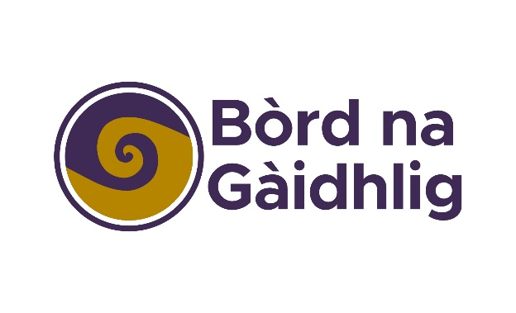

*Bha Duais Fastadh Cànainean na h-Alba air a leasachadh agus ga toirt gu buil le taic-airgid o Bhòrd na Gàidhlig agus GLIF (Gaelic Language Act Implementation Funding).*

*The Scottish Languages Employability Award was developed and implemented with support from Bòrd na Gàidhlig and the Gaelic Language Act Implementation Fund.*